MSBA STANDARD CONTEST REGISTRATION FORM

INSTRUCTIONS
1. INTRODUCTION
The MSBA Standard Contest Registration Form is an on-line, standardized method for band directors to submit their registration information for local contests as well as for the MSBA championships. When completing the information for the championships, please complete as much of the information as possible to reserve your place in the contest and then update the missing information at a later date. If you have any questions, please contact Dick Turner at csja1@fuse.net.
2. DIRECTOR INSTRUCTIONS: Completing the form.
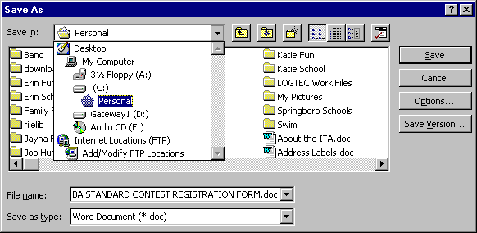
a. Download the MSBA Standard Contest Registration Form from the MSBA Web Site to your hard drive, saving it to your desktop (usually the top item listed in the "Save In" list:.

b. The downloaded file is a Word document template (.dot suffix). Double click on the file icon to launch Word, which will use the template to open a new untitled document (.doc suffix).

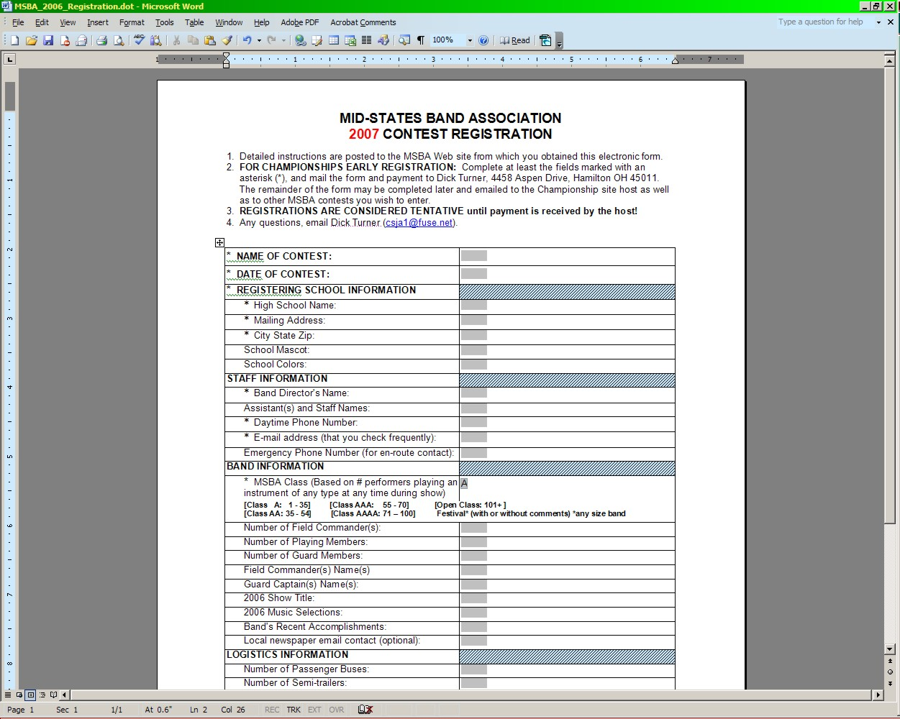
c. Once you have a new document open (verify by the document title appearing at the top of the window), enter the requested information by clicking in the gray text boxes, leaving the first two fields (Contest Name and Date) blank for now. You will only be able to enter information in the gray text boxes, but they will "grow" without limit to handle as much text as you need to enter. The only non-text box is the "MSBA Class" drop-down list, which functions like any other drop-down pick list.
d. When done entering the information (except contest name & date), save the document. If you have not previously saved it, you will be prompted for a name and location. This is your generic 2007 registration form, so give it a generic name such as "2007 MSBA Registration" and save it as a Word document (.doc suffix).
e. To register for a specific contest, open your generic registration form, complete the first two fields, and "save as" with a new name specific to that contest (e.g., "2007 MSBA Springboro Inv"). Repeat for each contest you wish to enter, saving each "final" form as a unique document.
f. Go to the MSBA Contest Schedule page, click on the email link for the contest of interest to open a new email to that host, attach the completed form for that contest, and send it. The host should reply, acknowledging receipt, and providing mailing instructions for the fee.
g. Send the applicable registration fee to the host by regular mail. Your email registration saves a lot of time and effort on both ends, but it is only TENTATIVE until the host receives your payment. Printing and mailing a hard copy of your registration form is not required, but you may if you wish.
3. CONTEST HOST INSTRUCTIONS: Using the data.
a. Receiving this form electronically means you can copy and paste the data into a spreadsheet rather than retyping it. The spreadsheet can then be used to populate your contest schedule, narrator's script, planning worksheets, and so on.
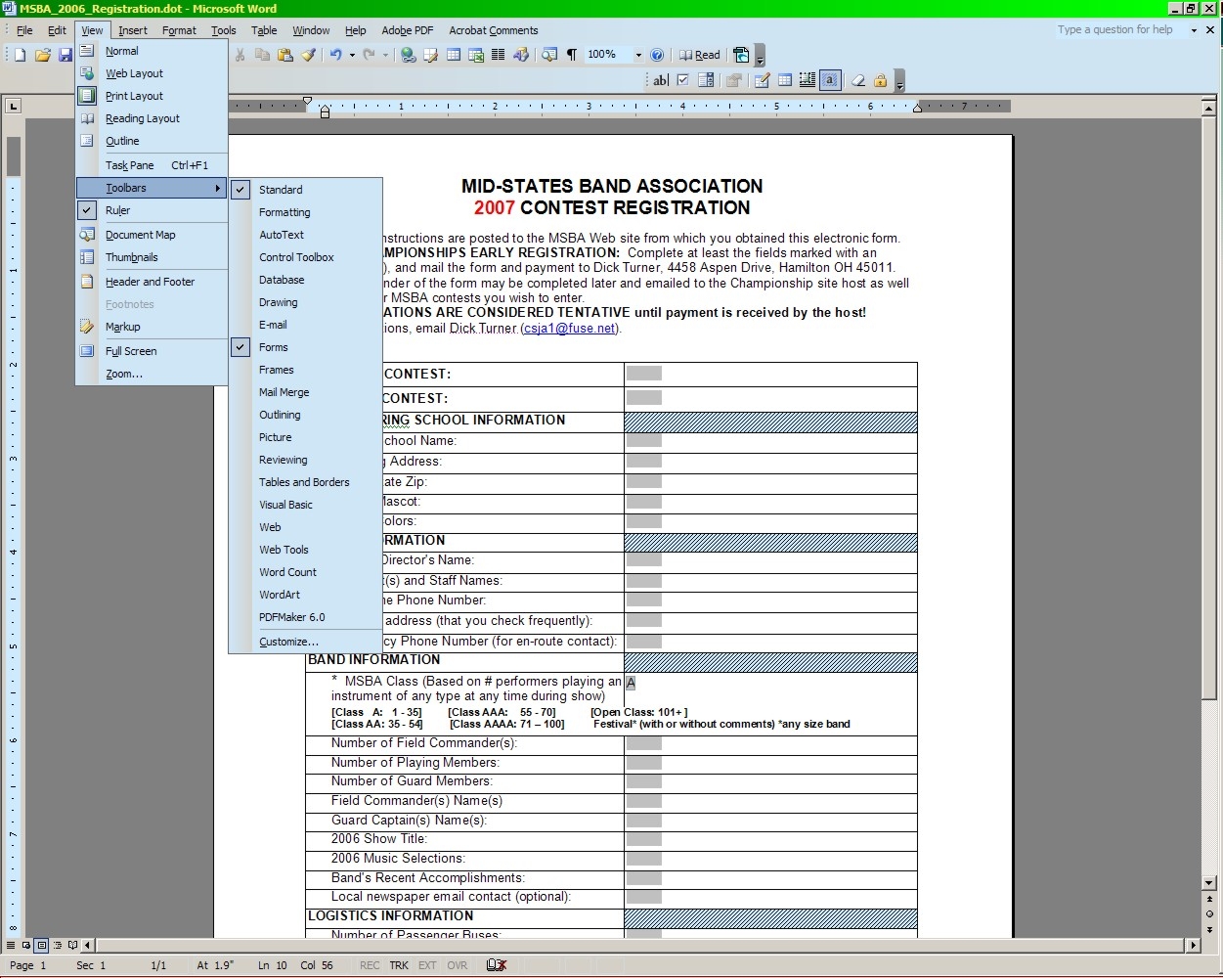
b. Open the registration form in Word. To extract the data, you must first unlock the form. To do that, place the forms toolbar in view. Click VIEW/TOOLBARS and select the "Forms" toolbar:

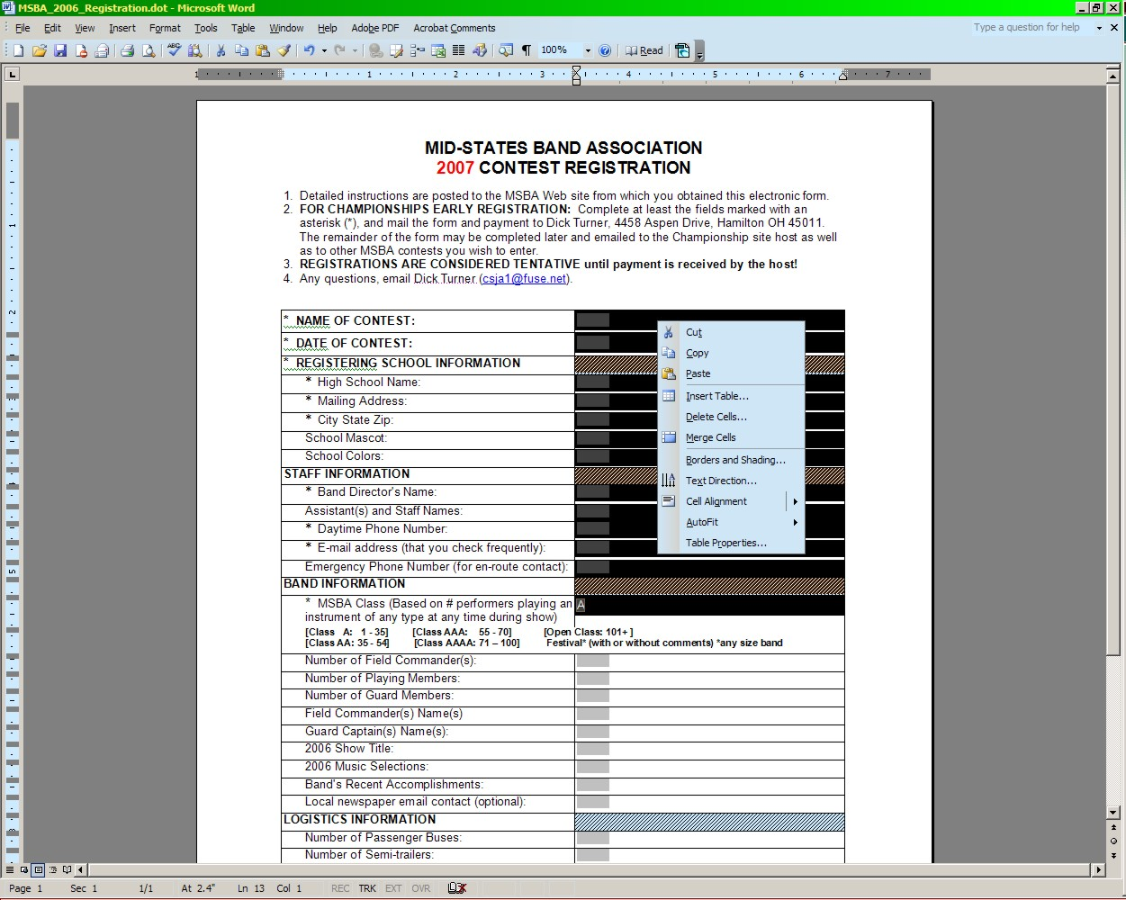
The Forms toolbar will appear as indicated. Click the padlock icon on the Forms toolbar to unlock the form.
c. Hover your cursor just above the right-hand column until it becomes a small black arrow pointing downward. Then click to select all the cells in that column, hover over any text field, and RIGHT click to bring up the menu as shown:
d. Click "Copy", and the information from the highlighted cells will be copied onto your clipboard.
e. Open your planning data spreadsheet. Most such worksheets are set up to have a Band's data running left to right, not top to bottom. To convert the columnar data to a row, go to a blank worksheet and place the cursor in the top left cell, right click, and select "paste." The data pastes in as a column. Then, select all those cells, right click, and copy them once more into the clipboard. Go to the actual planning data worksheet, place the cursor in the left-most cell in the next empty row, right click, and click "Paste Special", and select the "Transpose" option on the dialogue box. The data will paste in as a row.
f. From here, you have the full range of Office tools available, including Excel functions, linked mailmerge documents (narrator scripts), Access, etc. You also have our best wishes for a great contest!

